User Guide

Autonomous Flight

for

Drones on simulation

May 2018

Table of Contents

1 Introduction 3

1.1 Scope and Purpose 3

2 [How It Works? ] 4

2.1 MATLAB Installation and Compiler 4

2.2 Start Simulation 5

# Introduction

## Scope and Purpose

The purpose of this product is to autonomously fly the drone according to the coordinates entered by the user. During the flight, the drone will calculate the shortest route to the destination and will determine a new route to overcome the obstacle if there is any obstruction. Simulation will do that according to coordinates identified by user, drone will autonomous flight from the starting point to destination point and during this flight when the drone encounter the obstacle, it will aim to determine itself a new path and reach the destination point.

# How It Works?

**2.1 MATLAB Installation and Compiler**

To run the simulation program first of all you should install at least 2017 version of Matlab on your computer. You can enter MATLAB by double-clicking on the MATLAB shortcut icon (MATLAB 7.0.4) on your Windows desktop. When you start MATLAB, a special window called the MATLAB desktop appears. The desktop is a window that contains other windows. The major tools within or accessible from the desktop are

• The Command Window

• The Command History

• The Workspace

• The Current Directory

• The Help Browser

• Run and Time button

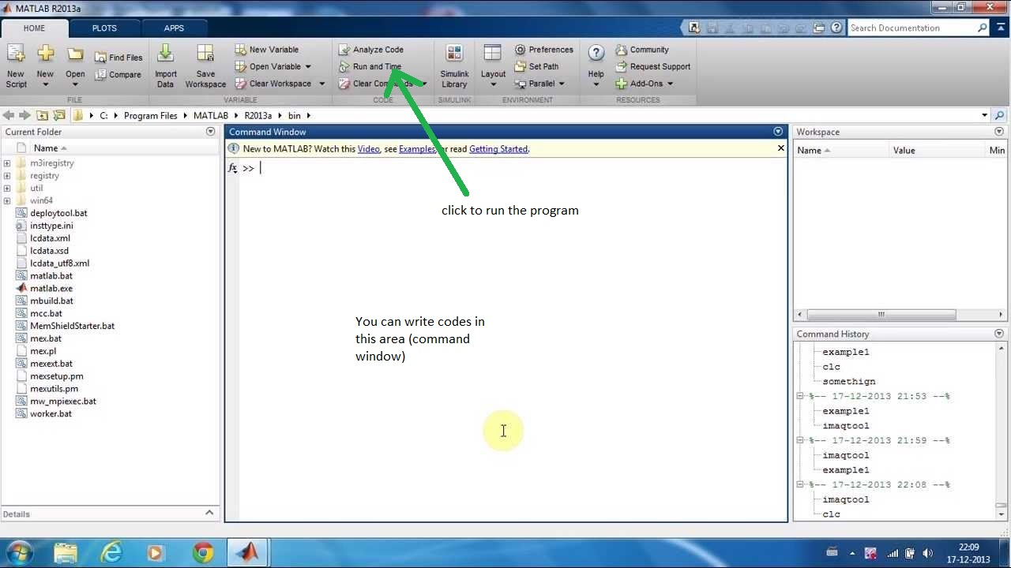

Figure 1.1: The graphical interface to the MATLAB workspace

**2.2 Start Simulation**

To run a program, first of all you have to write codes or copying to Command Window area. You can reach codes on our websites (www. .com). After write your codes this area you should save (Ctrl+S) and then click Run and Time button and you will see like a map

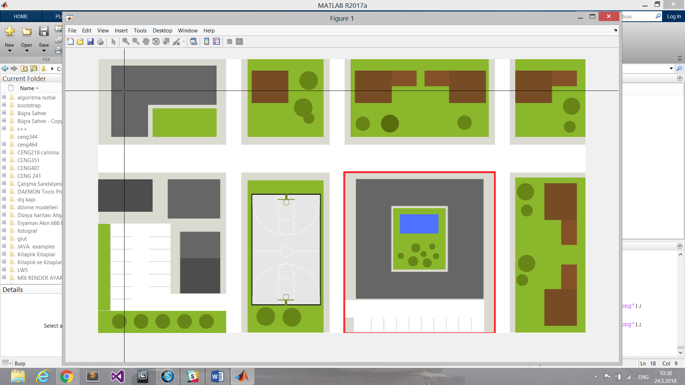

Figure 1.2: The graphical interface of map

To determine a coordinate on the map, you should use mouse and click a somewhere on you want to determine starting point and ending point. Then, the simulation will be start.

## Style Sheet Information

The following styles have been set up in this template. Avoid applying manual character formatting to the document. Applying these styles will assist in the conversion process if the document is to be laid out in a structured authoring tool, content management tool, or an HTML editor.

| Style Name | Apply to |
| --- | --- |
| Title | Title as listed on the cover page of the document |
| Subtitle | Subtitle as listed on the cover page of the document |
| Heading 1 | Chapter Name or Process or Workflow |
| Heading 2 | Subsection or SubProcess or Workflow step |
| Heading 3 | Subsection 2 or Procedure |
| Callout Block Copy Note | Notes, cautions or warnings, use arrow graphic on the left margin |
| Chapter Body Copy | Generic text following a heading |
| * Chapter Body Copy – Bullet | Unordered list within a section or subsection, sometimes within a Step to indicate alternative ways to do something. |
| * + Chapter Body Copy – Bullet 2 | A secondary unordered list, within a higher level ordered or unordered list |
| 1. Chapter Body Copy – Step | An ordered list (sequential) used in a procedure to indicate the order of actions to be taken |
| 1. Chapter Body Copy – Step a | A secondary ordered list, e.g. substeps in a procedure |
| Chapter Body Copy – Indent | Sets additional text inward so that it aligns with either Chapter Body Copy – Bullet or Chapter Body Copy – Step |
| Chart Body Copy | Text within a table |
| Chart Header Information | The first row of a table. |
| Caption | Descriptive text for a table or graphic. |
| Header | Text that appears at the top of each page. |
| Footer | Text that appears at the bottom of each page. |
| Chart Title and Footer Info | Copyright and other front matter preceding the Table of Contents; additional information used to footnote or provide a legend for a table. |
| TOC Heading | Heading used for Table of Contents, Table of Figures (if applicable), and the Document Revisions pages of the front matter to the document. |
| TOC 1 | TOC display information for a chapter. Generated automatically from Heading 1. |
| TOC 2 | TOC display information for a sub-section. Generated automatically from Heading 2. |
| TOC 3 | TOC display information for a subsection 2. Generated automatically from Heading 3. |
| [Template Instructions] | Guidance on building out the user guide. Should be deleted prior to publishing. |